SASQUATCH CHRONICLES
REVEALED

Compiled by: Alana Ennis
Dated 20th April 2015
This report has been compiled to showcase the current facts and evidence surrounding the Sasquatch Chronicles controversy.

It is up to the reader to make their own final conclusions.

DISCLOSURES

* Shannon Legro approved the publishing of her email.

* William Jevning preferred not to comment on Wes/Woody. Please respect his decision.

* WASRT approved their section to be published.

* Michael Crenshaw was contacted via facebook messenger at the date this report was published no response was received from him.

* Pictures and/or screenshots contained in this report have been cropped and resized for aesthetic purposes only. This has NOT altered the information contained.

* Every effort has been made to maintain the integrity of the data shown. Therefore original links have been provided at the end of the report.

TABLE OF CONTENTS

Date of Encounter……………………………………………………..5-7
Location and GPS Co-Ordinates………………………………8-10
Moon……………………………………………………….………………11-12
Solar Flare……………….…………………………………………….13-14
Weather……………………………………….…………………………15-18
WASRT…………………………………………………………………..19-26
Washington Department of Fish and Wildlife…….…27-28
Financial Information………………………………………….…29-33
William Jevning and Shannon Legro…………………….34-37
Wes and Woody Quotes…………………………………………38-39
Links…………………………………………………………….…………40-41

DATE OF ENCOUNTER

The date of the alleged encounter has been disputed. However, there are numerous references to the date. We will explore these references in greater detail.

Bigfoot Tonight Show - “Best of Worst of Bigfoot World 2012” Dated 16th December 2012. This is the first retelling from Wes Germer and his alleged encounter.

At time mark 32:23, Wes states, “This happened on the 16th of last month”.

At time mark 32:27, Bigfoot Tonight Show host states, “16th of November huh great Thanksgiving gift to you”.

Bigfoot Tonight Show – “Special Bigfoot Witness Show”
Dated 3rd February 2013. This is the first time Wes Germer and Woody Pratt retell their alleged encounter together.

At time mark 48:30, Wes states, “This was last November, just a few months ago”.

WASRT Email – Wes sent WASRT an email the morning after the event, this email is below.

From: "Wes Germer" <wesgermer@icloud.com> To: mojo@wasrt.com Sent: Friday, November 16, 2012 6:30:30 PM Subject: Bigfoot sighting
My brother and I were being encircled last night by them while in our car. We were on the back side of yacolt mt, kind of by sunset falls and we didn't see 1 we saw 3.

The validity of the above email was questioned. So WASRT were messaged via facebook to confirm the above email. This is their response:
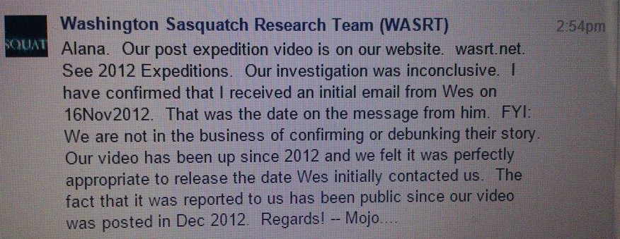

Conclusions on Date:

- Through Wes/Woody interviews on the Bigfoot Tonight Show and the subsequent WASRT emails, it is apparent that Wes/Woody alleged encounter occurred on either 15th or 16th November 2012.

- WASRT advised that the email released above was “cut” by them after the “we saw 3” comment. This was done to protect personal information that Wes had included (e.g. phone number address etc).

LOCATION
AND
GPS CO-ORDINATES

There has been confusion about the location. However, there are numerous references to the location. We will explore these references in greater detail:

Bigfoot Tonight Show - “Best of Worst of Bigfoot World 2012”
Dated 16th December 2012.

Time Mark 33:15, Wes states, “It actually happened up on Yacolt Mountain”.

Sasquatch Chronicles – Episode 87 “Attacks from the Community” Dated 19th March 2015.

Time Mark 42:42, Wes states, “Get your pens out, North is 45.82798, West is -122.22641”.

The GPS co-ordinates given by Wes and Woody show Jack Mountain and NOT Yacolt Mountain. The details for Jack Mountain are:

Jack Mountain
Jack Mountain is the 17th highest mountain in Washington State. It is one of the 10 non-volcanic peaks in Washington State over 9,000 feet.
Elevation: 2,766 m
First ascent: 1904
Prominence: 1,284 m
Mountain range: North Cascades

Picture showing location search on Google Earth
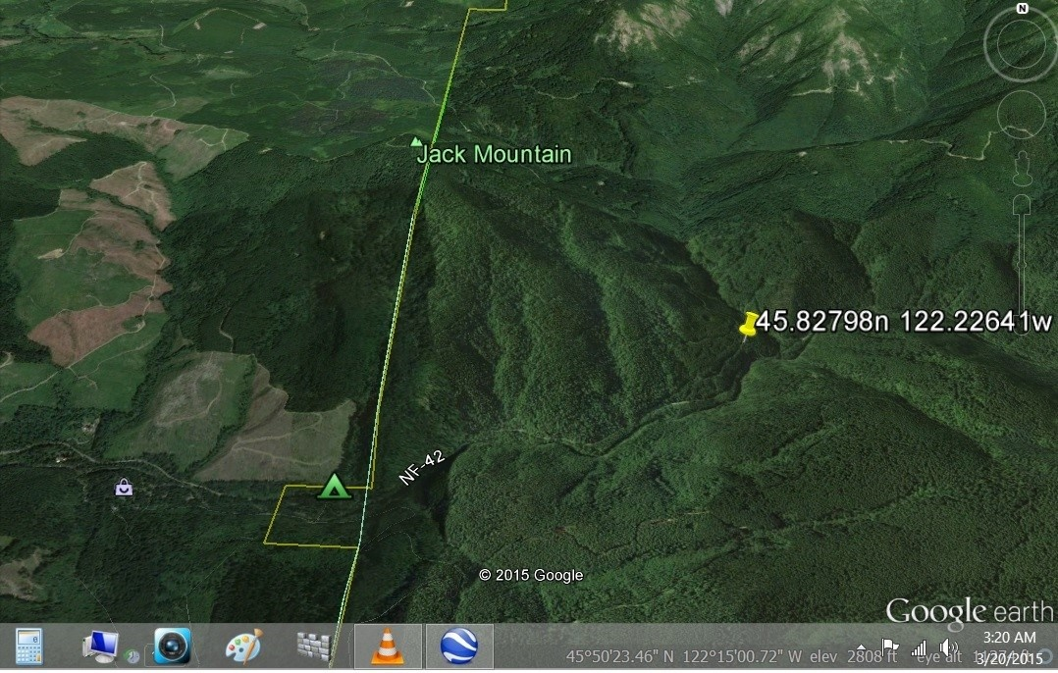

Picture showing location search on Google Earth:
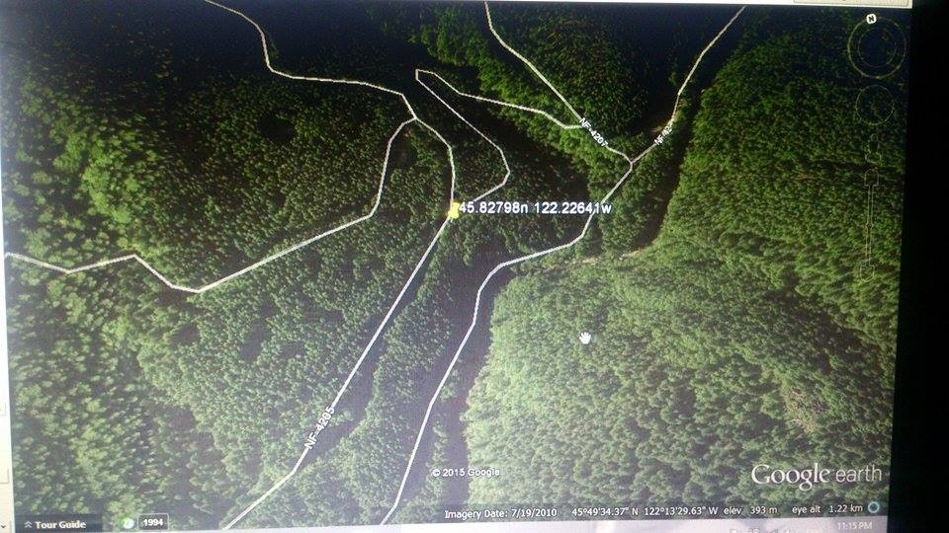

Conclusions on Location:

- The GPS co-ordinates provided do NOT match up to Yacolt Mountain. Instead they show Jack Mountain.

- Notice there are also various roads in and out of the area.

- The alleged encounter did NOT occur on Yacolt Mountain.

- Yacolt Mountain is approximately 10 miles West of this location.

MOON

There has been a lot of confusion about the moon and the role it plays in the alleged encounter. We will explore this further:

The Moon has 4 Primary phases and 4 Intermediate phases each month (average of 29 day cycle). The Primary phases of the Moon for November 2012 are as follows:

Third Quarter: 6th November 2012.
New Moon: 13th November 2012
First Quarter Moon: 20th November 2012.
Full Moon: 28th November 2012.

Information for the moon on the 15th and 16th November 2012 are as follows:

Date Illumination Position to Horizon MoonRise MoonSet
15th 6.0% moon under horizon 9:23am 6:26pm
16th 13.3% moon under horizon 10:20am 7:36pm

  15 | 
  16 | 

Conclusions on the Moon

- The moon was under the horizon on both dates during the time the alleged encounter occurred (2am to 5am).

- The moon was set early on both dates (6:26pm and 7:36pm respectively). This means that there was no moon present in the sky after the “moonset” times.

- There was also little illumination on both these dates. Illumination is needed from the moon in order to “see in the dark”.

- There was no light source provided from the moon on either of these dates.

SOLAR FLARE

There has been confusion about the Solar Flare on 16th November 2012. The Moon data proves there was no moonlight on the night of the encounter. It has been suggested that a “Solar Flare” was responsible for the light on the mountain during the alleged encounter. We shall explore this in greater detail:

See the article below posted on the Sasquatch Chronicles Blog dated March 20th 2015:
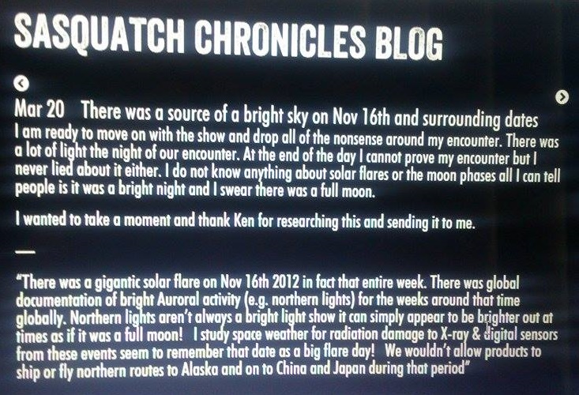
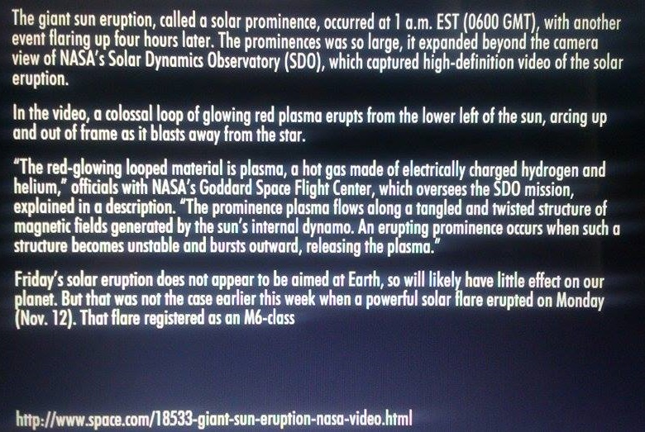

Conclusions on Solar Flare

- If you read the last line of the article it clearly states, “Friday’s solar eruption does not appear to be aimed at Earth, so will likely have little effect on our planet.”

- The solar flare on the 16th November 2012 was NOT aimed at Earth, therefore no light source from the solar flare would have been present anywhere on Earth on that date.

WEATHER

The weather information for the 15th and 16th November 2012 are as follows:

Thursday 15th November 2012

Time | Weather | Temperature | Dewpoint | Humidity | Winds | Visibility
2:03AM | Mist and Fog | 39°F/4°C | 39°F/4°C | 100% | N 0 MPH | 3mi.
2:26AM | Mist and Fog | 39°F/4°C | 37°F/3°C | 93% | N 0 MPH | mi.
2:31AM | Mist and Fog | 39°F/4°C | 39°F/4°C | 100% | N 0 MPH | 0.75mi.
2:53AM | Fog | 39°F/4°C | 39°F/4°C | 100% | N 0 MPH | 0.25mi.
3:04AM | Fog | 39°F/4°C | 39°F/4°C | 100% | N 0 MPH | 0.5mi.
3:13AM | Mist and Fog | 39°F/4°C | 39°F/4°C | 100% | N 0 MPH | mi.
3:21AM | Mist and Fog | 39°F/4°C | 39°F/4°C | 100% | N 0 MPH | 3mi.
3:53AM | Mist and Fog | 41°F/5°C | 39°F/4°C | 93% | N 3 MPH | 6mi.
4:29AM | Mist and Fog | 41°F/5°C | 39°F/4°C | 93% | N 0 MPH | mi.
4:38AM | Mist and Fog | 41°F/5°C | 39°F/4°C | 93% | N 0 MPH | 1mi.
4:53AM | Mist and Fog | 41°F/5°C | 39°F/4°C | 93% | N 0 MPH | 0.75mi.

Friday 16th November 2012

Time | Weather | Temperature | Dewpoint | Humidity | Winds | Visibility
1:53AM | Cloudy | 45°F/7°C | 37°F/3°C | 76% | N 0 MPH | 10mi.
2:53AM | Mostly Clear | 43°F/6°C | 37°F/3°C | 81% | E 3 MPH | 10mi.
3:53AM | Cloudy | 43°F/6°C | 37°F/3°C | 81% | N 0 MPH | 10mi.
4:53AM | Mostly Cloudy | 43°F/6°C | 37°F/3°C | 81% | N 0 MPH | 10mi.
Snow Map – 15th November 2012
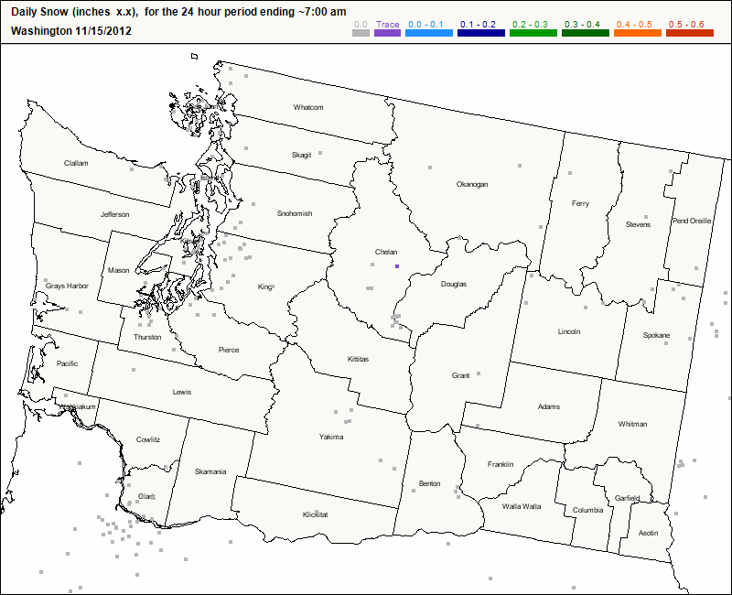

Snow Map – 16th November 2012
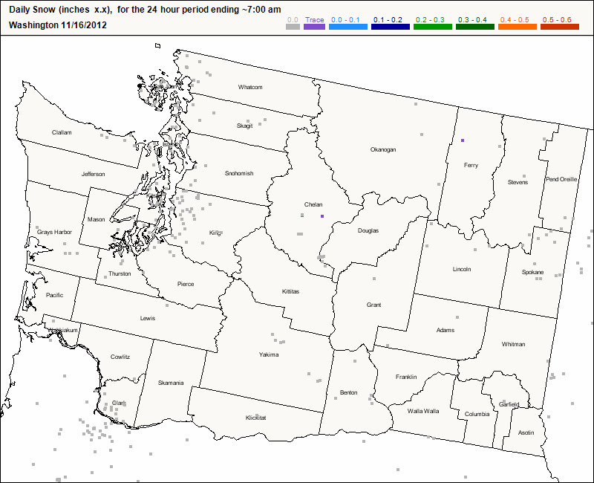

Conclusions on Weather

- There is mist and fog during the alleged encounter times on the 15th November 2012

- There was cloud coverage during the alleged encounter times on the 16th November 2012.

- There was no snow in Washington State on either of these dates.

- The sky was NOT clear on either of these nights due to mist, fog and cloud coverage.

WASRT

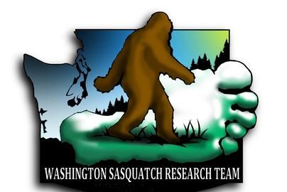
*logo used with permission by WASRT ;)

The following is the archived website report I received from WASRT. It shows the written account of the alleged encounter that Wes had emailed to Mojo to post on his website:
Mojo, Dean and John of WASRT traveled south on December 15th 2012 to investigate the below multiple Sasquatch encounter as reported to us last month. The team originally planned to conduct a 5-day/4-night expedition, but it was cut short by a significant wind storm and approaching heavy snow. Before departing the area however, the team was able to search the area of the encounter for evidence. Additionally, the team set up their thermal imaging camera and ReconyX rapid fire trail camera outside camp in hopes of capturing evidence of the creatures approaching camp at night.
In the woods --- surrounded by a group of Sasquatch!
I received an email from a gentleman last month describing an incredible ordeal that both he and his brother endured that totally astounded me! The man asked me to call him so he could talk to me about the experience. I interviewed both him and his brother and found their story to be very credible. Two experience outdoorsman that will never take a step into the woods again. The two men asked to remain anonomous. The incident occured in Washington State, several hours south of Seattle. Here is their story:
Date: 11/16/12
Time of encounter: 2:00 AM

My brother and I were driving towards the spot where the incident happened. At the bottom of the mountain we noticed several deer that seemed to be bolting from the mountain. Being hunters we thought it was so odd to see several deer this far down and seemed they seemed be staying close to the road. My brother and I joked about all the times we hiked through the forest trying to find deer and when we are not hunting and their all here. We drove a few miles and saw another deer or two doing the same as the ones before and again we drove a few more miles and I saw another deer that seemed to be heading away from the mountain. I remember we both commented how odd this behavior was but we kept heading up the mountain.

Now we were on top of the mountain, as we came around and started heading up the road and about 100-200 feet from where we stopped I started to have this overwhelming and terrifying feeling like we were being watched. We came to this spot that seemed to be another road so my brother started going down it, but as we headed down the incline I realized this was not another road. It was more or less a traveled path but I was afraid that we were going to get stuck so I told my brother to stop, so he did.

The sky was clear and the moon was to the rear of the vehicle. All of the leaves were now off of the trees and on the ground. Behind the car it was clear and open and the area was lit up from the moonlight however, we were facing a down an incline towards the mountain and it was impossible to see anything. My brother stepped out of the car while it was running and the lights on and started to walk to the front of the car, I immediately told him to get back into the car, shut the door, crack the windows and turn the car along with the lights off. I asked him to just listen. My brother said "it was dead silent" I said "it's so quiet you could hear a pin drop…right?" We both commented on how quiet the forest was, we have both been in the forest so many times and have never heard it so silent. Now to the driver’s side we heard what sounded like heavy footsteps, slowly approaching the vehicle, if I were to guess I would say about 40 feet away and with all of the leaves on the ground it was impossible to walk silently. My brother whispered if I heard that, which I replied I did and as soon as we both whispered the footsteps would stop. My brother asked if I thought it was a deer than immediately said it sounded way to big and heavy to be a deer. I asked him if he thought it was a beer than I immediately said that it’s walking on two feet and not only that it seemed to be walking more like a person. We both sat there puzzled because every animal we have encountered in the woods will run the other direction as soon as they pick up a person’s scent or see a person.

The footsteps started up again but now they were on the passenger side but these sounded different. They still seemed to be footsteps but sounded much lighter and quick stepped. Instead of taking 4 heavy footsteps and stopping and then repeating like the one on the left this one would take 5 or 6 really quick steps and stop. Both footsteps were approaching at the same time now and seemed to be about 35-40 feet away. My brother and I would stop from listening and ask what each other thought it was and again, both footsteps would immediately stop. Now directly in front of us we heard a completely different step of footsteps, these steps didn’t sound as big as the one to our left but much bigger than the one to our right and it too was approaching the car. My brother asked if he should start the car and get out of here and I told him “No I do not want to provoke a fight, if whoever this is wants to fight than well fight but I do not want to provoke anything until we find out what is going on here.” It is important to note that at this time we pulled had our pistols out and had them down low just in case. This just didn’t make any sense to me, how could people not only seem to hear us whisper, a whisper so low that at times I could not even hear my brother and how are they walking around when it’s so dark without any issues?

My brother looked at me and said that we are being surrounded, I asked him “I know but by what?” I didn’t want anything to get out of control and wanted us to keep a level head so I told him to close his eyes and just use his ears and give me a count. I need to know how far away the one on his left is and how close he is after moving towards the car and I would do the same for the two on our right. At about what we both guessed was 15-20 feet we heard a different noise.

This noise was coming from the rear of the vehicle and was not footsteps, it sounded like a large person on his belly doing a military crawl and he was coming towards the rear. My

brother asked again if he should start the car to which I replied “Don’t do anything, if they are cool we will be cool if they’re not cool we won’t be cool” about the time I finished saying that we heard a growl. The growl sounded like an agitated growl. Than this thing quickly moved towards us again and again growled. This time the growl sounded more agitated than the one before. Now this thing was pretty close to the rear of the car and growled again. This was the deepest growl I have ever heard in my life and now it was not an agitated growl like two before, it was a very low, angry and deep growl.

Now being probably a few feet from the rear bumper it growled again. This growl was so deep, so low I felt this growl. My brother commented that “The growl shook the car.” The growl didn’t shake the car but it felt like being in front of a large speaker that is pumping out a lot of bass, the growl shook us. I was so shocked I was trying to tell my brother to start the car but I really couldn’t talk. The last time it growled it seemed to be right next to the back window probably an inch from the rear bumper and this last growl was something that I will never forget, it felt like being hit with a baseball bat. So I pulled it together and told my brother “Start the car slowly, turn on the lights slowly and back us out of this hole slowly” and to his credit he did.

My brother turned the car around and drove about 30-40 feet in the direction of heading back down the mountain. He then stopped the car and shut it off. I asked him what he was doing to which he didn’t reply. I told him to turn the head lights off and he said that he just needed a minute. I understood what he meant because I felt the same way, I felt somewhere between waking up from a deep sleep and being groggy to feeling like I just took a beating. It’s so hard to explain why we both felt like that. My brother turned the lights off and as we sat there he asked if I see that in the tree directly to our left and above us. As I looked up, it looked like a black blob with a head placed on it (no neck) sitting in the tree moving to the left and then to the right. My brother turned and asked if I am seeing the same thing to which I told him I did. We both looked back up and it was gone.

To my right I could hear what sounded like breathing but the only thing I can liken it to be if a really fat guy just got done running and was breathing hard but at the same time he was trying not to breathe hard. It was about 60 feet to our right. Now that we were facing the moon light and the area was wide open we could actually see. The area has trees with white bark on them and so they stick out. In my rear side mirror I could see three of these trees and I looked off to my right and was trying to listen to the breathing I noticed a black flash in the mirror. I couldn’t tell you the size or what it looked like but it would block the white trees than move and the movement seemed to be inconsistent. I trying to tell myself I didn’t see anything and about the same time my brother asked if I heard that noise behind the car. My brother said that we are being surrounded again and at this point I have had enough and wanted to leave. He agreed and as he was about to start the car we saw it.

This was the largest thing I have ever seen in my life. It walked across the road from left to right and walked slow and in a way it almost like it wanted to make sure we saw it. It walked like a tough guy with his chest out. My jaw dropped, it was about 10-12 feet tall

and had shoulders about as wide as I am tall. It walked like a man but not quite like a man. It’s hard to describe the movement on how the knees and feet moved. The arms were way to long for any man as they seemed to almost reach his knees. It was huge, so large I could see all five fingers on its hand as it walked. The size and muscles on it were unbelievable. It stopped about 100 feet or less from us and went behind a small tree. I tried to tell myself my eyes were playing tricks until I heard my brother catch his breath and ask if I “saw that!” I told him I did. He asked if he should drive out of here and I told him that it was still there and that’s the only road out. I can’t describe how big this thing really was, at least 1,000lbs…easy. This thing was a dark color almost black and would sneer at us. I say sneer because of its body language it would peak out from the tree and from its body language it seemed like it had every intention of getting us. After what seemed like forever of watching it come out and seeing it sneer at us over and over it went behind the tree and a lighter color one popped out from the same area. My brother says white but it might have been light gray, it’s hard to put into words how it moved. It came out leaping and took one leaping step, was across the road and gone. The road this thing leaped across would take a normal person 12 or more steps to get across.

This whole time we had been whispering and I remember both of us yelling “What was that!” at the same time. The movement was so smooth and so fast my brother said it seemed like it floated across the road. He is right, it’s the only way to describe how it moved. The light colored one was not as big as the black one that walked across the road but it was very large and had more of an athletic build. Not quite the steroid build of the other one. I have seen bear bolt from us at about 300 hundred yards and all you see is a black flash and it’s gone but this was much faster.

The black one had come out from behind the tree and went down to his belly into a military crawl off to the right and into the brush. How he dropped into the military crawl was so odd, almost machine like. I told my brother to get us the hell out of here. So he started the car and we drove off.

If this whole thing could possibly get any weirder I remember looking at his clock and telling him his clock was off because it was not 5am. I even pulled my phone out to show him and could not believe it was 5am. I would have bet my life we were only there for 30min maybe 45 min tops and there was no way we were there from 2am to 5am having all of this going on. To this day we still do not understand what happened to the time, maybe fear and shock. As we came down the mountain I kept telling my brother we have to tell someone before someone goes up and gets killed. My brother said no one would believe it, I agreed but I would feel better saying something to someone and having them call us crazy than saying nothing and having some guy get killed up there. This experience has ruined the one thing in life I really enjoyed and that was being outdoors. I will never hunt, fish or camp again.

Post on WASRT facebook page. They did a “recon” of the area on Sunday 18th November 2012 before their final investigation in December 2012:
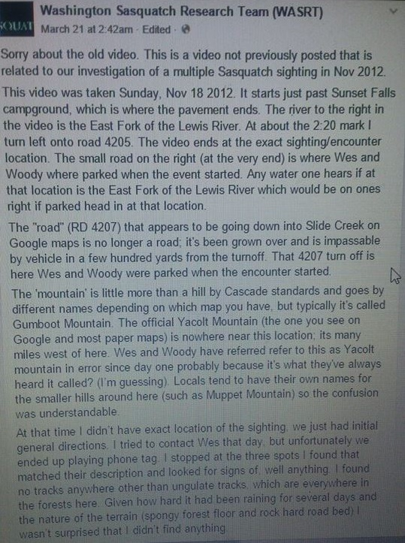

Screenshot of Video mentioned above (taken 18th November 2012), posted on WASRT facebook page:
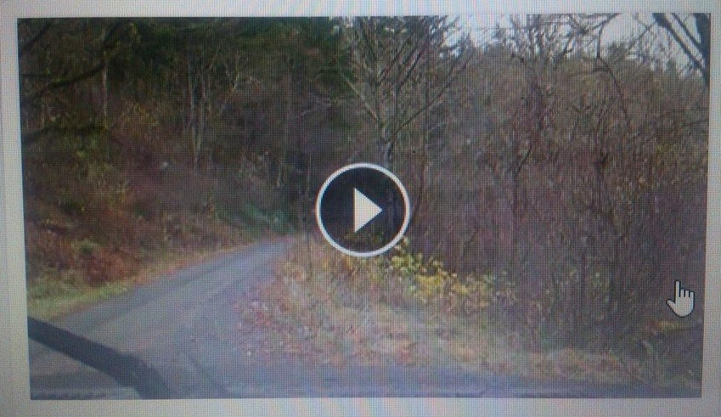

Screenshot of Video of Wes/Woody Encounter Location on WASRT website:
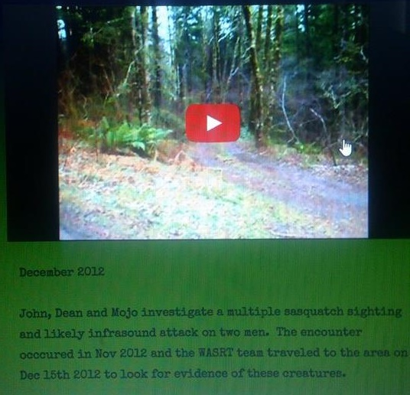

Conclusions on WASRT

- WASRT received an email from Wes Germer dated 16th November 2012.

- WASRT received a written report from Wes Germer, report dated 16th November 2012.

- WASRT conducted a recon of the alleged encounter area on 18th November 2012.

- WASRT conducted an investigation of the alleged encounter area during an expedition on 15th December 2012.

- Wes/Woody alleged encounter could not have occurred after 18th November 2012 as WASRT had completed reconnaissance of the area for Wes/Woody.

WASHINGTON DEPARTMENT OF
FISH AND WILDLIFE

A request was made to the Washington Department of Fish and Wildlife. This information is below:

PDR #15160 Alana Ennis ack_cl
Rick, Deborah E (DFW)
To
larn_crawford@yahoo.com
CC
Gibbs, Theresa A (DFW) Lasiter, Susan E (DFW)
Mar 27
Dear Ms. Ennis:

As required under Washington’s Public Records Act (RCW 42.56.520), this email is to notify you that your request for public records was received on March 19, 2015, and assigned PDR #15160 for tracking purposes.

You requested the following:

Information reported to DFW via phone in November 2012. Around the 15th, 16th, 17th November 2012 but really could be any time in November 2012. The person who allegedly made the call to WDFAW was Wesley Germer or Woody Pratt.

After a thorough search by both the Enforcement and Wildlife Programs, we have no records to provide. This email response completes and closes your request to PDR #15160.

If you have any questions, you may contact Theresa Gibbs at (360) 902-2623, or at Theresa.Gibbs@dfw.wa.gov.

Sincerely,
Debbie Rick for Theresa Gibbs
WDFW Public Disclosure Office

Conclusions on Washington Department of Fish and Wildlife

- They received no call, email, complaint etc from Wes Germer or Woody Pratt during November 2012.

FINANCIAL
INFORMATION

There has been confusion as to who receives the membership funds. We shall explore this below:

Trademark Information:

SASQUATCH CHRONICLES - Trademark Details
Status: 630 - New Application - Record Initialized Not Assigned To Examiner

Serial Number86562148
Word MarkSASQUATCH CHRONICLES
Status630 - New Application - Record Initialized Not Assigned To Examiner
Status Date2015-03-16
Filing Date2015-03-12
Attorney NameScott T. Griggs

Statements
Description of MarkThe mark consists of underbrush within the lower portion of the words SASQUATCH CHRONICLES.
Goods and Servicescoffee cups
Goods and Servicesclothing, namely, t-shirts, sports caps and hats
Goods and Servicesentertainment and educational services, namely, programming on crypted ape and nominal-like creatures accessible by radio and the Internet

Classification Information
International Class021 - Household or kitchen utensils and containers (not of precious metal or coated therewith); combs and sponges; brushes (except paint brushes); brush-making materials; articles for cleaning purposes; steelwool; unworked or semi-worked glass (except glass used in building); glassware, porcelain and earthenware not included in other classes. - Household or kitchen utensils and containers (not of precious metal or coated therewith); combs and sponges; brushes (except paint brushes); brush-making materials; articles for cleaning purposes; steelwool; unworked or semi-worked glass (except glass used in building); glassware, porcelain and earthenware not included in other classes.
US Class Codes002, 013, 023, 029, 030, 033, 040, 050
Class Status Code6 - Active
Class Status Date2015-03-16
Primary Code021
International Class025 - Clothing, footwear, headgear. - Clothing, footwear, headgear.
US Class Codes022, 039
Class Status Code6 - Active
Class Status Date2015-03-16
Primary Code025
International Class041 - Education; providing of training; entertainment; sporting and cultural activities. - Education; providing of training; entertainment; sporting and cultural activities.
US Class Codes100, 101, 107
Class Status Code6 - Active
Class Status Date2015-03-16
Primary Code041

Current Trademark Owners
Party NameCrenshaw Media Group LLC
Party Type10 - Original Applicant
Legal Entity Type16 - Limited Liability Company
Address3020 Brookgreen Court
Prosper
TX
75078

Correspondences
NameSCOTT T. GRIGGS
AddressGRIGGS BERGEN LLP
12900 PRESTON ROAD
SUITE 204
DALLAS, TX 75230

Trademark Events
Event DateEvent Description
2015-03-16NEW APPLICATION ENTERED IN TRAM

See the paypal receipt below for monthly membership fee via the paypal payment method:


Here are the details of a company search:

Registration Details
Business name
CRENSHAW MEDIA GROUP LLC
File Date
09/17/2014
Filing type
CORPORATE
Source
TEXAS SECRETARY OF STATE
Last update
09/26/2014

Registered agent
Agent Name
MICHAEL E CRENSHAW
Street
3020 BROOKGREEN CT
Locality
PROSPER, TX 75078
County
COLLIN

Other Businesses Registered By
MICHAEL E CRENSHAW
Note - registrations for dissimilar business entities suggest the registered agent is a lawyer or third party filing on behalf of the business owner(s)
- CRENSHAW WHITLEY ASSOCIATES L L C, SPRING, TX
- MIKE C TODD W HOLDINGS LLC, PROSPER, TX
- MIKE C TODD W HOLDINGS LLC, PROSPER, TX
- CRENSHAW S LUXURY COACHES LLC, PROSPER, TX
- CRENSHAW S LUXURY COACHES LLC, PROSPER, TX
Conclusions on Financial Information

- Paypal payments are being made to a “mcrenshaw”.

- “Mcrenshaw” has been identified as Michael Crenshaw from Texas.

- The Sasquatch Chronicles trademark application has the Applicant listed as “Crenshaw Media Group LLC”.

Questions on Financial Information

- Why is he receiving the membership payments?

- Why does he “own” the Sasquatch Chronicles trademark?

- Why does a podcast need a “financial backer”?

- Did he receive the funds from the “Audible campaign”?

WILLIAM JEVNING
AND
SHANNON LEGRO

William Jevning

Questions have been asked as to the amount of knowledge William Jevning had of any possible hoax. Once I became aware of a possible hoax I emailed him. These emails are below:

First email to Will explaining my concerns:
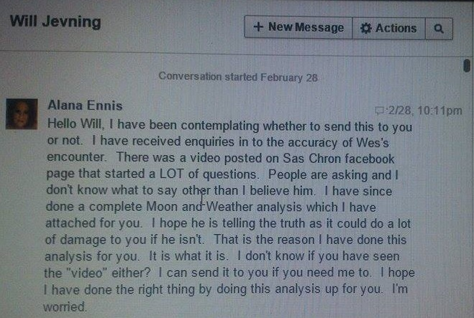

This is his reply:
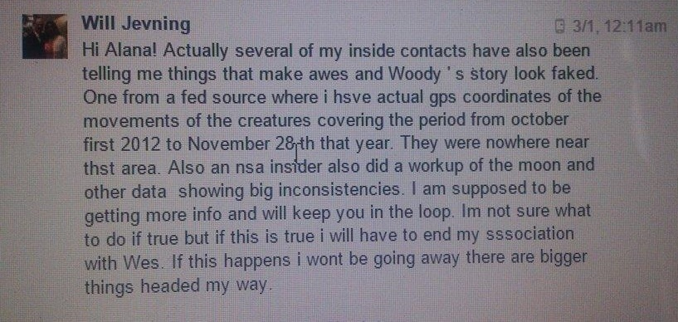

Shannon Legro

A lot of questions have been asked of her unexpected appearance on to the show. Where did she come from etc? Shannon has emailed me responses to some of these questions. Her responses are below:

Shannon Legro
To
ALANA CRAWFORD
Today at 12:04 AM
So, I'll just go down the list of questions here...

1) Where did I come from as far as my inception on the show.

-Sometime last year, I began using Facebook to try and connect with more people interested in the subject. I absolutely zero ideas about getting "discovered" for a show.
I have been interested in the subject for almost 8 years now, and had been researching 100% alone, and without any connections to social media. I had a Facebook account for years, and finally decided I would "come out of the Bigfoot closet" and utilize FB to try and further my knowledge on the subject. I joined the Bigfoot Hotspot FB group, (along with many other groups) as I had been listening to Hotspot from the beginning- and began posting and interacting there. I believe that is where Wes took notice of me. He messaged me on FB, and from there... I ended up being invited to be part of the show.

2) Wes and I living in both Las Vegas and Henderson, NV

-I grew up in Las Vegas, NV. If you've never visited...Henderson and Las Vegas are melded together into one metropolis. I have lived, as it would seem Wes did as well, with my address in both "cities." They are one in the same though, technically. Wes and I never met or spoke prior to my contact with him on FB last year.

3) Why did I not investigate the validity prior to joining the show

-One of the aspects that drew me into their show, was Wes and Woody finishing each other's sentences in the re-telling of their encounter. Some, obviously took that as a bad thing, a red flag... I suppose my ears, took it differently. I did take their encounter at face value, and with Will being a part...it of course helped with credibility and ease of choice.

4)Why did I not undertake my own investigation when claims of a hoax came out

-When this all started to come to light, I almost immediately had things being sent to me. Plus, I had been told a number of times that the proper people were looking exactly where they needed to be, to have this be proven without a shadow of a doubt, it was a hoax. Hanging back with my mouth agape, is about all I could muster with as shocked as I was.

Hope that helped clear things up.
Shannon
Conclusions on William Jevning and Shannon Legro

- There is no evidence (that I could find) that shows or proves that William Jevning or Shannon Legro were involved in the alleged hoax perpetrated by Wes Germer and Woody Pratt.

- There is no evidence (that I could find) that shows or proves that William Jevning or Shannon Legro were aware of the alleged hoax before joining Sasquatch Chronicles.

WES
AND WOODY
QUOTES

The following are direct quotes from Wes/Woody recounting various parts of their alleged encounter. The quotes were collected from multiple shows:

The TreeSquatch

Woody

“It was really, it was fairly small”.

“Well I agree with you and that’s, I would say, it’s something about your size”.

Wes

“I would say it was a little bit bigger then me, not by much, but a little bit bigger then me”.

“It’s kind of a blob, black blob with a head”.

“It looked like, just kind of a blob, black blob with a head, on it, in a tree kind of like a person but like a Monkey”.

The Moon

Wes

“I think there was a full moon that night”.

“Behind us the moon was coming in”.

“There is a full moon coming in on us, and it’s a clear night”.

“The moon has lit everything up at this point”.

Woody

“There was a full moon, full moon, stars, no clouds”.

“The moon was coming in from the south”.

“The moon was coming up”.

LINKS

http://www.cocorahs.org/Maps/ViewMap.aspx?type=snow&state=WA

www.weatherforyou.com/reports/index.php?forecast=pass&pass=archive&zipcode=98675&pands=yacolt%2Cwa&place=yacolt&state=wa&icao=KVUO&country=us&month=11&day=30&year=2012&dosubmit=Go

http://www.timeanddate.com/moon/usa/seattle?month=11&year=2012

http://web.archive.org/web/20130105235607/http://wasrt.com/

http://www.timeanddate.com/calendar/aboutmoonphases.html

https://trademarks.justia.com/865/62/sasquatch-86562148.html

http://www.statelog.com/crenshaw-media-group-llc-prosper-tx

http://www.blogtalkradio.com/bigfoottonightshow/2012/12/17/best-of-worst-2012-bigfoot-world

